**Homework 1.**

**Colabrators: Monico**

**Please create the codes and make screen captures of output of each question.**

**1. Personal Information**

Write a program that displays the following information:

* + Your name
  + Your address, with city, state, and ZIP
  + Your telephone number
  + Your college major

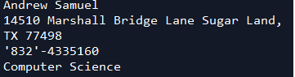

**2. Sales Prediction**

A company has determined that its annual profit is typically 23 percent of total sales. Write a program that asks the user to enter the projected amount of total sales, then displays the profit that will be made from that amount.

The Sales Prediction Problem

Hint: Use the value 0.23 to represent 23 percent.

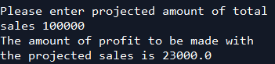

**3. Land Calculation**

One acre of land is equivalent to 43,560 square feet. Write a program that asks the user to enter the total square feet in a tract of land and calculates the number of acres in the tract.

Hint: Divide the amount entered by 43,560 to get the number of acres.

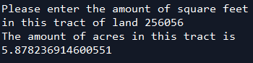

Turn-in Method: Please zip all your python files. Then turn in the zip file and this word file containing screen captures.